**Experiment-4: To implement the restrictions on the table**

**Student Name:- Neha Sharma UID:- 20BCS4576**

**Branch:- CSE-IOT Section/Group:- A**

**Semester:- 3rd Date of Performance:- 9/09/2021**

**Subject Name:- DBMS LAB Subject Code:- 20CSP-233**

**1. Aim/Overview of the practical:** To implement the restrictions on the table.

**2. Task to be done:** Implementation of DDL and DML commands of SQL with proper Input queries syntax and the output.

**3. Theme/Interests definition( For creative domains):**

* **Adding A Not Null Contraint:-**

**Command:- Not Null**

**Purpose of command**:- If you want to ensure that a column must always have a value i.e., it should not be left blank, then define a not null constraint unit. Null value can be inserted into the columns of any data type. Not null constraint can only be applied at column level.

**Syntax:-**

* Define data column level: Column name data type (size) NOTNULL

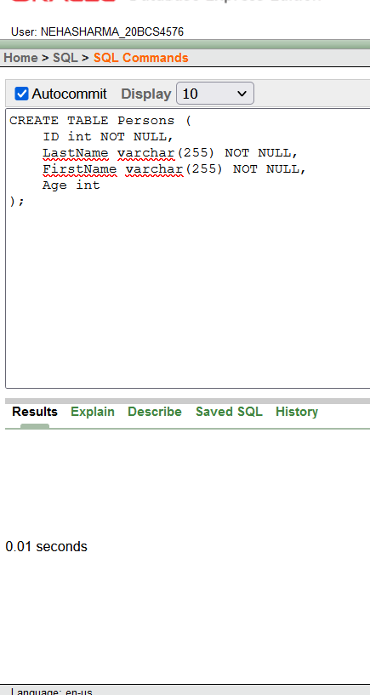

**Output:-**

This was the output when a record with null value was tries to inserted in the person table. This verified the not null constraint.

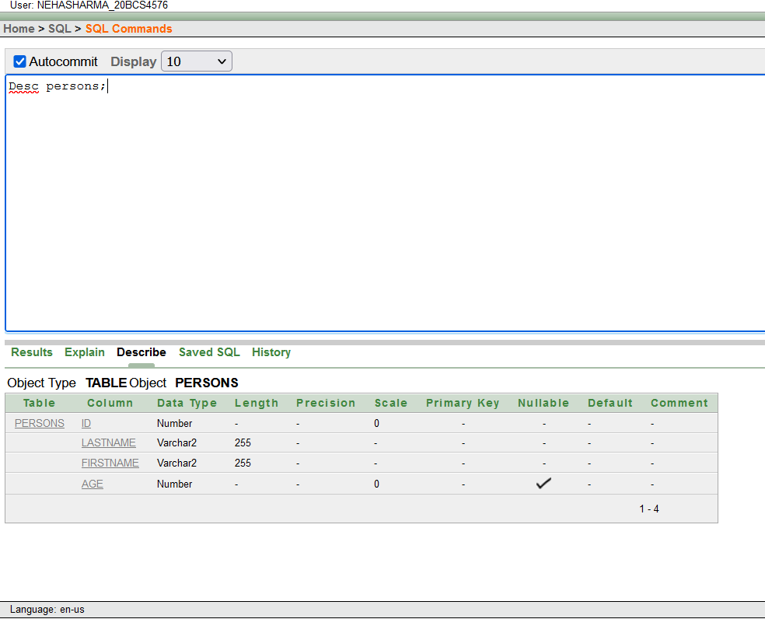

* **Adding Unique Constraint**

**Command:- Unique**

**Purpose of command:-** The UNIQUE constraint ensures that all values in a column are different.

**Syntax:-** Define at column level

Column name data type (size) Unique

This output came when ID was same. It meant that you cannot enter duplicate values. This shows that unique key is verified.

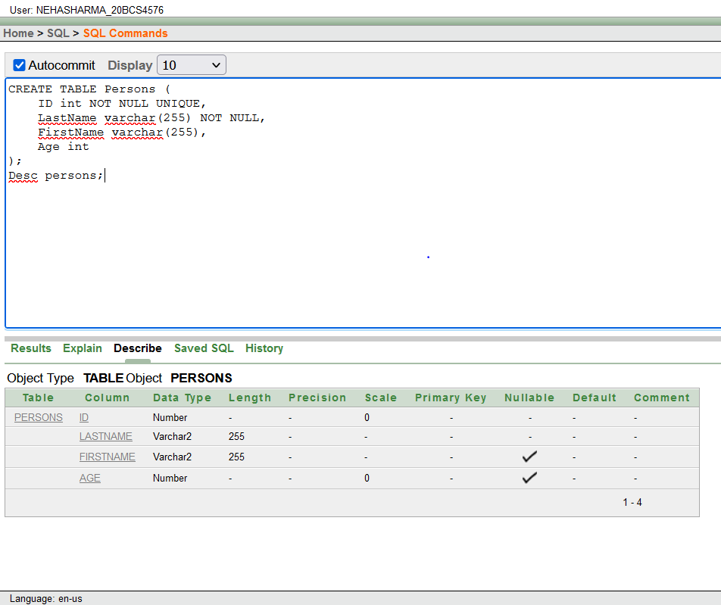

* **Adding A Unique Constraint:-**

**Command: - Unique**

**Syntax:-** Defined at table level:

Unique (column name1, column name2,….., column name n)

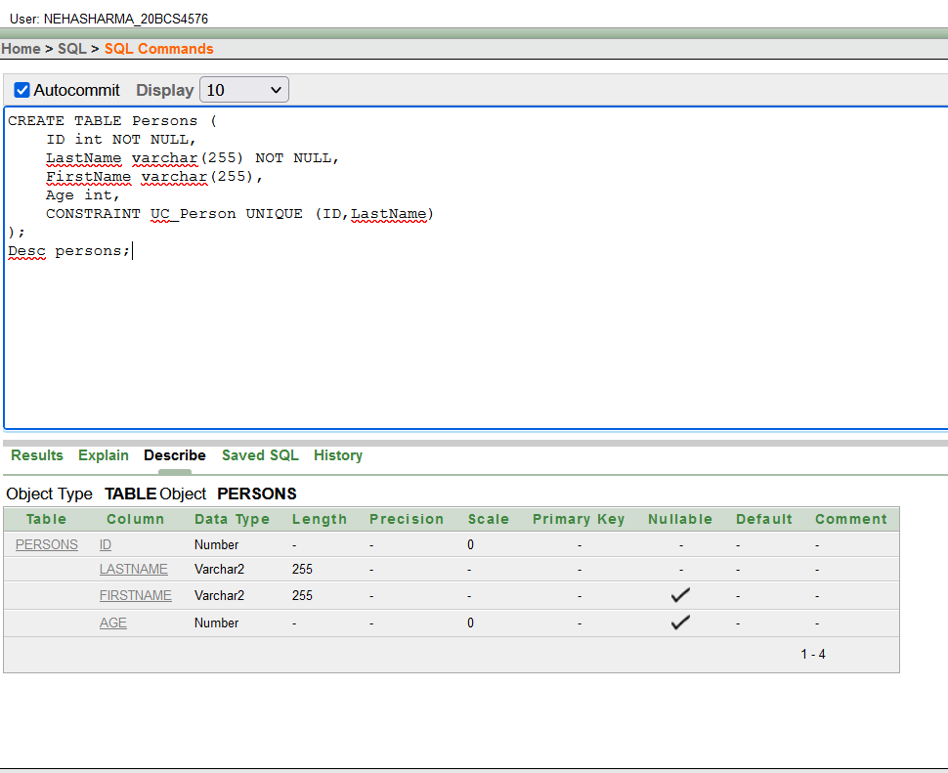

* **Adding A Primary Key:-**

**Command: -** Primary Key

**Purpose of command**:- The PRIMARY KEY constraint uniquely identifies each record in a table. Primary keys must contain UNIQUE values, and cannot contain NULL values.

**Syntax:- •** Defined at column level:

Column name data type (size) Primary Key

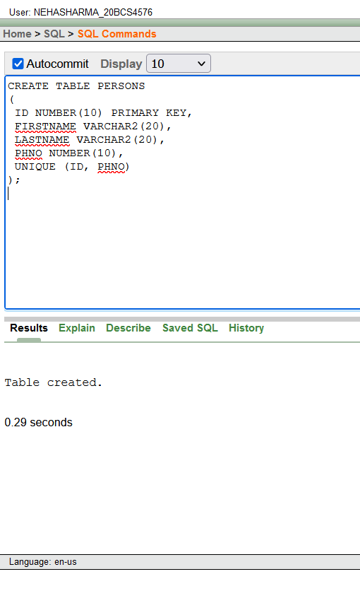

This output was recorded when duplicate value was tried to enter into the PERSONS table, which shows that primary key is applied accurately.

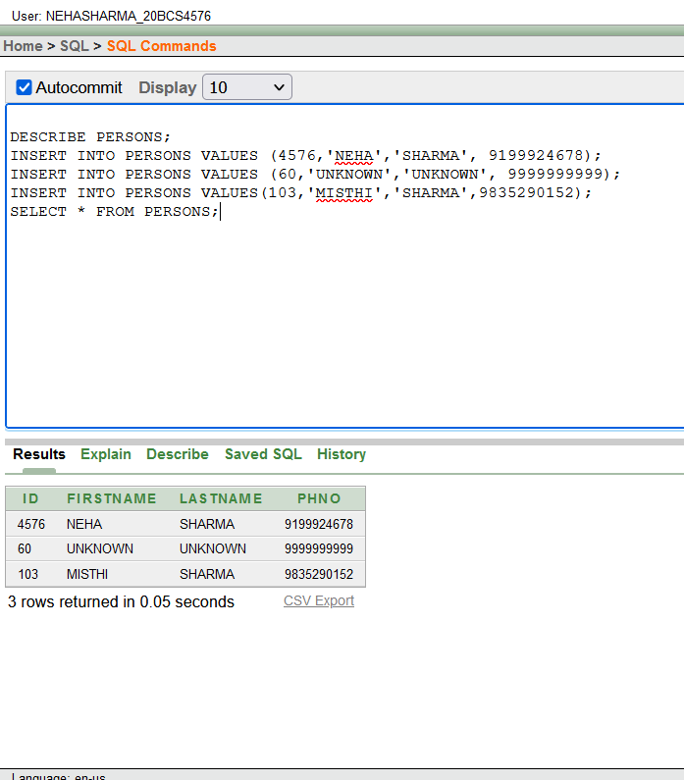

* **Adding A Foreign Key:-**

**Command:** - Foreign Key

**Purpose of command:-** A foreign key is a column or group of columns whose values are derived from the primary key or unique key of some other table.

**Syntax:-** • Defined at column level: Column name data type(size) References table name [(column name)] [On Delete Cascade]

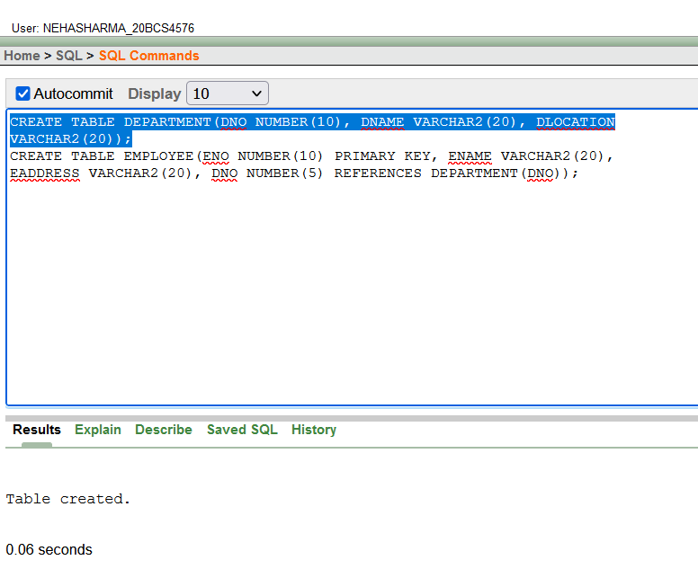

**OUTPUT**-Both level of definition of foreign key has the same output.

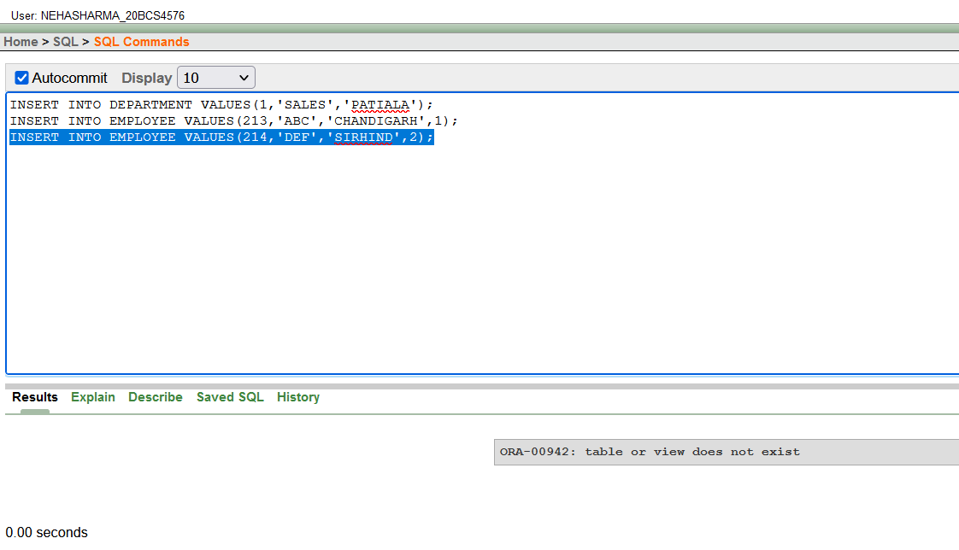

* **Adding A Check Constraint:-**

**Command:**-Check

**Purpose of command**:- The CHECK constraint is used to limit the value range

that can be placed in a column.

**Syntax:-** • Define data column level:

Column name data type (size) CHECK(logical expression)

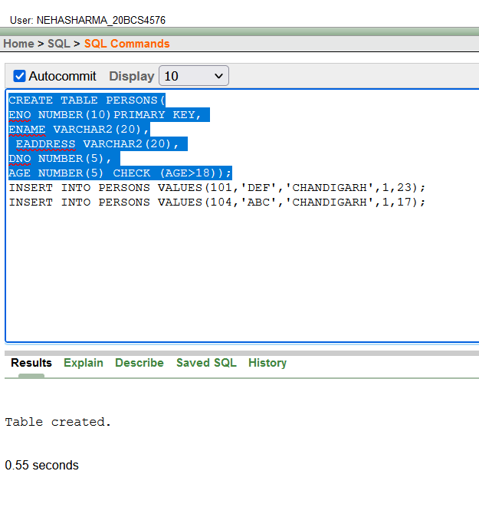

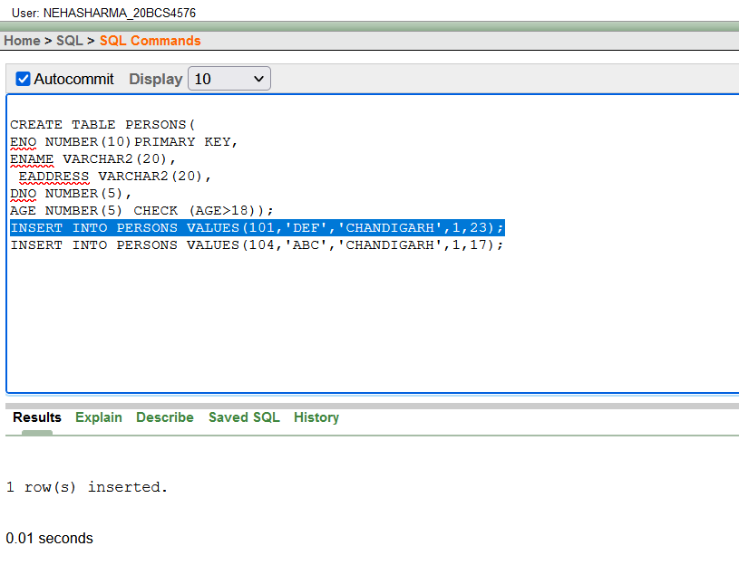

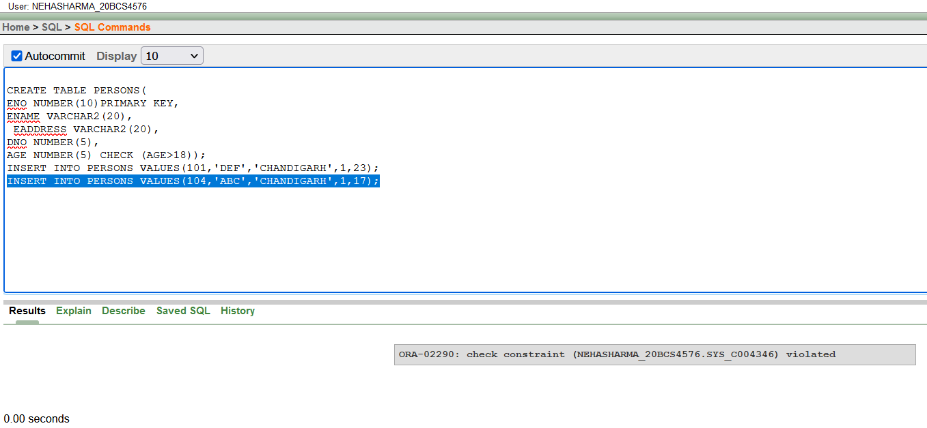

**4. Observations/Discussions(For applied/experimental sciences/materials based labs):**

We observed the different syntax in SQL and their implementations.

**Learning outcomes (What I have learnt):**

1. Learned about different SQL commands
2. Various new querying methods.

**Evaluation Grid (To be created as per the SOP and Assessment guidelines by the faculty):**

|  |  |  |  |
| --- | --- | --- | --- |
| Sr. No. | Parameters | Marks Obtained | Maximum Marks |
| 1. |  |  |  |
| 2. |  |  |  |
| 3. |  |  |  |
|  |  |  |  |